Serious Incident Investigation Report
Report prepared by | (Lead Investigator Name)  v1 (date)
College / Division
School / Unit
Location of Incident
AIMS Reference
Head of School / Director
Supervisor
Date of incident
Investigation commenced
Notifiable Incident (if yes – note reference number and date of notification

- Description of Incident
- Equipment being used at the time?
- Environmental conditions that may have contributed to the incident?
- Evidence collected and reviewed
- Findings and failure of any preventative risk controls.
- Were there any deficiencies in operating procedures?
- Contributing factors to the incident
- Root causes
- Corrective Actions | Action | Person Responsible & Due Date
- Person(s) Responsible for the Investigation | - Lead –  - Support -

- Timeline of events

Time / date | Event
Day
Date XX/XX/XXXX
Time

Appendices

Appendix 1 – Incident location(photos)

Appendix 2 – SafeWork acknowledgement of notification

Appendix 3 – ICAM Analysis - from the AIMS ICAM Investigation Tab
- Select the contributing factors, then select “investigate” for each contributing factor. Select if the factor is a root cause.

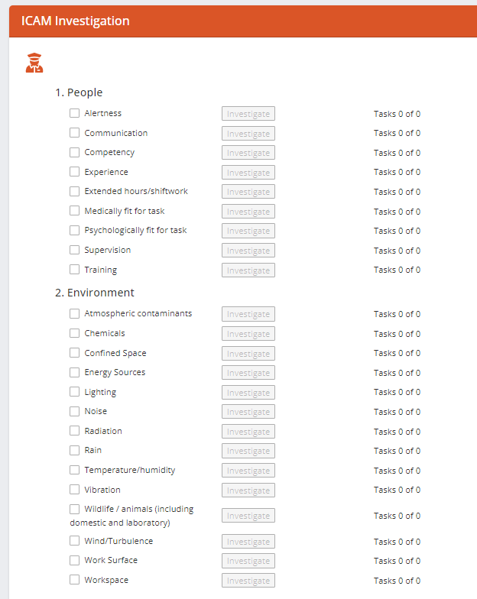

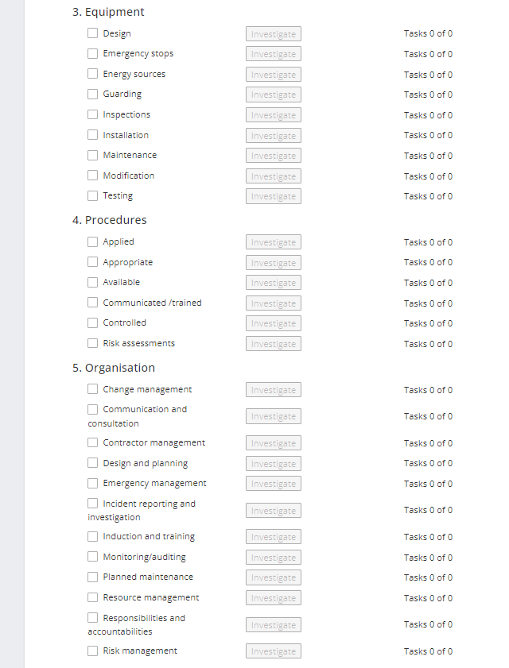

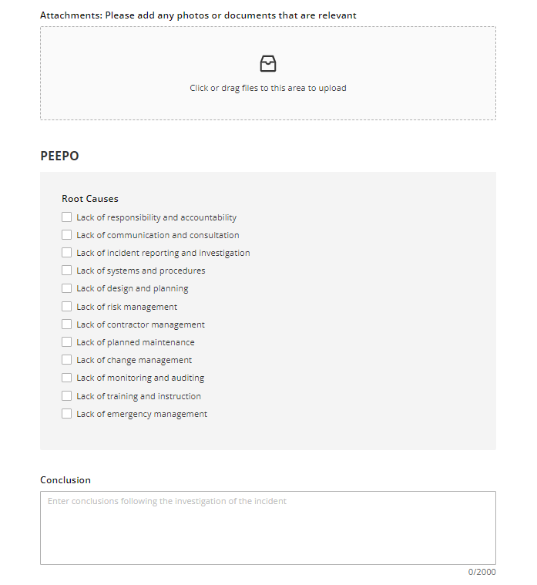

- Complete “why” questioning for each contributing factor and add a corrective action if required. Select if the factor is the root cause.

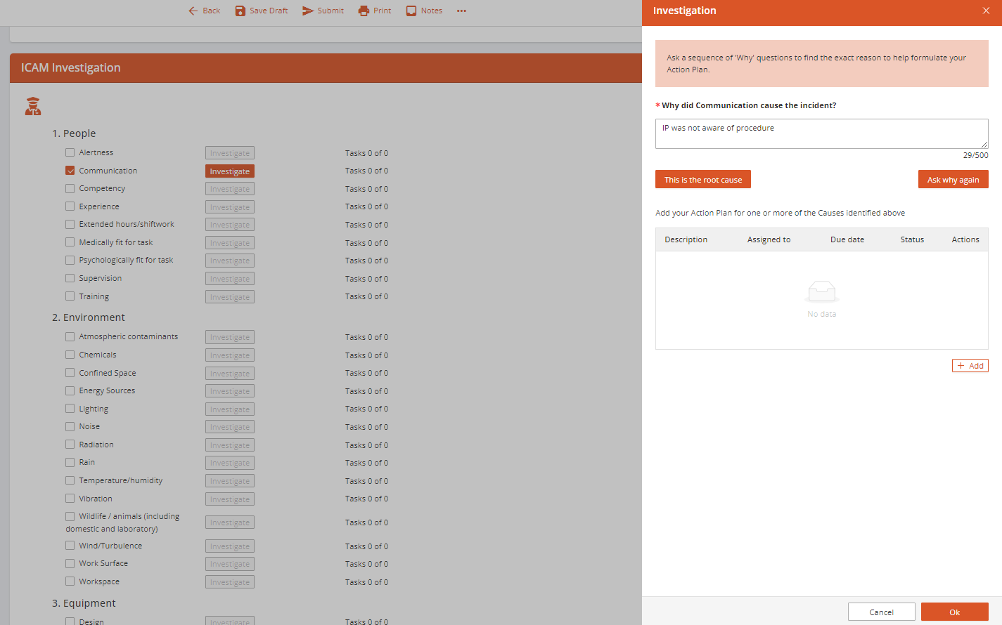

- Select the root cause(s) in the PEEPO section. Complete the Conclusion, Recommendations and Learnings.

